EVALUATION AND RESULTS OF THE SURVEY
This questionnaire administered to respondents over the telephone and some respondents were interviewed face-to-face in their homes. I have questioned 30 individuals and each of them responded properly. I used SPSS software package for understanding the results and creating cross tabulations. Respondents’ opinion about the consuming US brands according to deterioration analyzed with the survey regarding to their similar sex, age, marital status, educational level and employment status. Considering this information;
- 40 % of respondents are female and 60 % of respondents are male
- 40 % of respondents are aged between 18 and 30 years, 16.7 % of respondents are aged between 31 and 40 years, 26.7 % of respondents are aged between 41 and 50 years, 16.7 % of respondents are aged 51 years and over.
- 63.3 % of respondents are single and 36.7 % of respondents are married.
- 40 % of respondents were graduated from high school or below, 43.3 % of respondents studied undergraduate, 16.7 % of respondents studied postgraduate.
- 56.7 % of respondents are working and 43.3 % of respondents are not working.
Table 3: Gender Status Table 4: Education Level
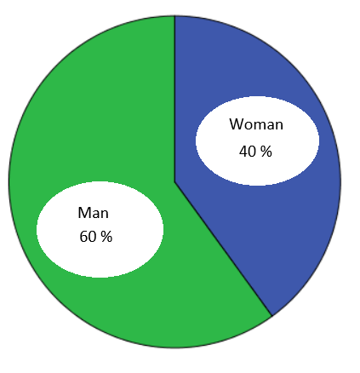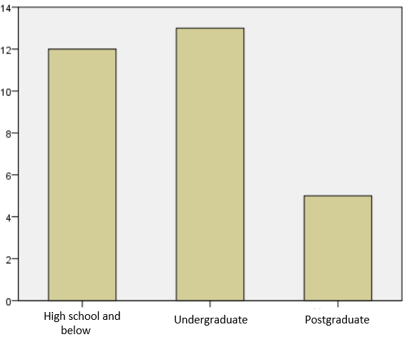
The first question was inquired into and reported whether respondents use US brands or not.
Table 5: Results in terms of Age
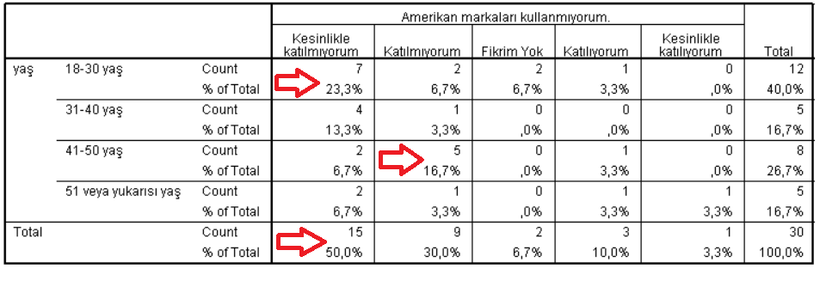
23.7 % of the respondents are aged between 18 and 30 years strongly agree with using US branded goods.
16.7 % of the respondents are aged between 41 and 50 years agree with using US branded goods.
50 % of all respondents strongly agree with using US branded goods.
The second question was inquired about understanding consumers demand for US brands after the deterioration.
Table 6: Results in terms of Employment Status
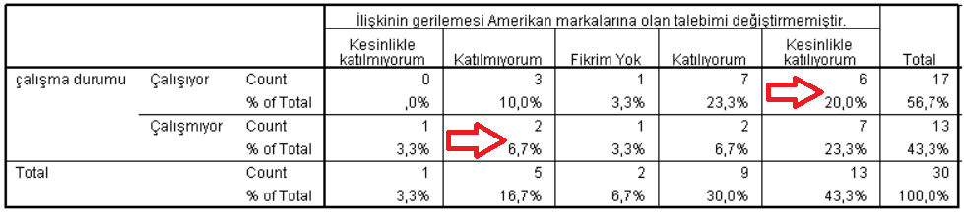
20 % of the respondents are working that strongly agree with their demand did not change by the deterioration.
6.7 % of the respondents are not working that agree with their demand changed by the deterioration.
The third question was inquired into after the deterioration consumers pay attention about using goods whether these are US branded or are not.
Table 7: Results in terms of Gender
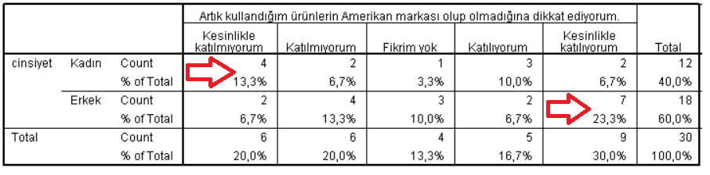
13.3 % of the respondents are female who strongly disagree with paying attention to using US branded goods after the deterioration.
23.3 % of the respondents are male who strongly agree with paying attention to using US branded goods after the deterioration.
The fourth question was inquired to understand respondents’ opinion about Turkey’s future US imports.
Table 8: Results in terms of Education Level
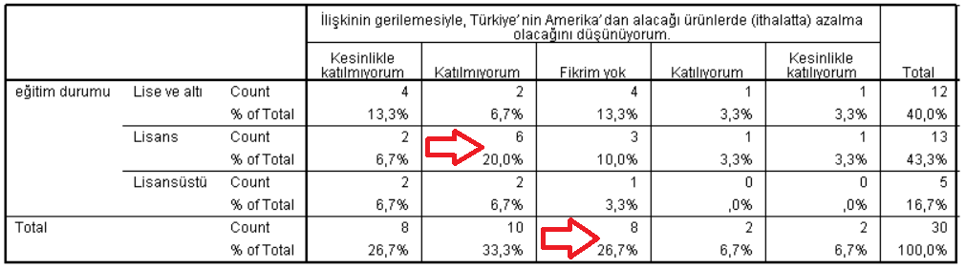
20 % of the respondents studied undergraduate who disagree with Turkey’s US imports will be declined.
26.7 % of all respondents have no idea about Turkey’s future US imports.
The fifth question was inquired into understand the respondents whether guide others to not use the US branded goods or not.

Table 9: Results in terms of Marital Status
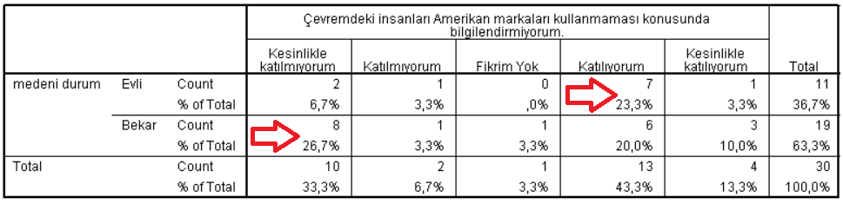
23.3 % of the respondents are married who disagree to guide others for not using US branded goods.
26.7 % of the respondents are single who strongly agree to guide others for not using US branded goods.
All of the individuals responded questions considering only shopping goods. While answering the questions, individuals considered and thought daily buying or personal consumption, not as government purchases or bulk buying. The first question expressed clearly that the most of the respondents are using US branded goods and half of them are aged between 18 and 30 years. This means that, the young generation highly involved in using US branded goods. Moreover, we can see similar consuming behaviour on the sixth table. Most of the respondents (73.3 %) are still apt to consume US branded goods. However, according to the seventh table, some of the respondents started to check whether they are using US branded goods or not after the deterioration. Thus, even though the deterioration appeared, the respondents ignored to give up consuming US branded goods and only led them to check what they are consuming.

