PORTRAIT OF THE RELATIONS: TURKEY’S DECLINING IMPORTS FROM THE U.S.

Name-Surname-Student ID
  - PSI 207

PORTRAIT OF THE RELATIONS: TURKEY’S DECLINING IMPORTS FROM THE U.S.

Name-Surname-Student ID
PORTRAIT OF THE
RELATIONS: TURKEY’S
DECLINING IMPORTS
FROM THE U.S.

Prepared for Prof. Dr. Mahir NAKIP
Chairperson of International Trade Department
Instructor of PSI 207 Course
Cankaya University

Prepared by NAME SURNAME
Department of Political Sciences and International Relations
Student ID
Cankaya University

December 28, 2018

ABSTRACT

In this study, I analyzed the downward trajectory of US-Turkish relations which affected consuming US branded goods by Turkey. Moreover, the main reasons of relationship breakdown and how the Turkish Government adopted a particular attitude against US products included. I also reviewed what people think about consuming US branded goods according to current US-Turkish relations. I used some supportive articles, national and international statistical services, columns and researches for a better understanding of the topic. I prepared a questionnaire to reflect consumers opinion about US branded goods. This report also includes figures, statistics and graphs.
Key Words: US Goods, US Branded Goods, Turkey–US Relations, US Products in Turkey, Consuming US brands, Boycotting of US branded goods

ACKNOWLEDGEMENT

I would like to offer my special thanks to my instructor of INTT-309 course, Prof. Dr. Mahir NAKIP because of his patience and sharing his experiences with us.

TABLE OF CONTENTS

Abstract…………………………………………………………………………….…..2
Acknowledgement……………………………………………………………………..3
Table of Contents..………………………………………………………………….....4
List of Figures and Tables..……………………………………………………………5
1.Introduction……………………………………………………………………….....6
1.1.History of The Deterioration…………....…………………………………6
2.Literature Review…..………………………………………………………………..7
3.Regulations and Consequences……………………………………………………...9
3.1.The Responses of Governments…………………………………………...9
3.2.Declining Trade and Boycotting…………………………………………..10
3.3.Currency Crash…………………………………………………………....11
4.Methodology………………………………………………………………………..12
4.1.Research Design…………………………….…………………………….12
4.2.Research Details……………………………………………………….….12
5.Evaluation and Results of the Survey………………...……………………………..12
6.Conclusion………………………………………………………………………......16
7.References…………………………………………………………………………..17
8.Appendix……………………………………………………………………………19

LIST OF FIGURES AND TABLES

Table 1- New Duties on American Origin Products…………………………………...9
Table 2- U.S. Trade in Goods with Turkey…………………………………………...10
Figure 1- Currency Chart – USD to TRY…………………………………………….11
Table 3- Gender Status………………………………………………………………..13
Table 4- Education Level……………………………………………………………..13
Table 5- Results in terms of Age……………………………………………………...13
Table 6- Results in terms of Employment Status……………………………………..14
Table 7- Results in terms of Gender…………………………………………………..14
Table 8- Results in terms of Education Level………………………………………...15
Table 9- Results in terms of Marital Status…………………………………………...15

1. INTRODUCTION
The US-Turkey trade partnership was on an uptrend before the deepening diplomatic rows and it fluctuates over and over because of every new political tensions show up. These disagreements also have affected consumers. Turkish citizens might become to side against US products. These political stances divided Turkish consumers to supporters, refusers, the consumers who have no idea about developments and affected their consuming behaviour for US brands. The deterioration through the trade, should be examined in three main topics: regulations and consequences, what governments said and what movements have done, currency drops through sanctions. Considering and evaluating indicators, the current trade amounts and Turkey’s foreign-dependent position show this deterioration decreased Turkey’s US imports and this disagreement mainly has economical effect for individuals. According to the Office of the United States Trade Representative (2017), there is an obvious decline in the United States trade surplus with Turkey in 2017 which is a 75.1% decrease. Apparently, the decrease will become a more serious problem with current situations and stimuli if the conflict continues.
1.1. History of The Deterioration
Actually long before the US pastor Andrew Brunson imprisoned, the reasons of the deterioration goes a long way back and already there was a basis for the declining trade. Köse (2018) points out that, US-Turkey relations are jeopardized semi-annually and these cyclical crises increasingly get worse the inherent basis of bilateral relations day by day.
These series of crises make the simultaneous effect on current trade partnership and lead to a stalemated way. The last situation just aggravated the current disagreements and triggered possible trade downsizing. Arslan, Dost and Wilson (2018) point out that indeed, existing discussions started during the Obama administration — Obama’s support of YPG and PKK, also criticizing the coup attempt by way of impugnment affected relations. Recently, the election of Donald Trump in November 2016 has created a perception of re-establishing US-Turkish relations whether on a deteriorated or pleasant way. Because of these endless political stances and developments, Turkey’s US import is influenced and it seems not clear for future procedures.
2. LITERATURE REVIEW
In this section, the studies related to the subject in US-Turkish relations and consuming US branded goods are included. Literature is obtained from articles, national statistical services and columns.
Arslan, Dost & Wilson (2018) explained the historical relationship between the two nations and emphasized the reasons of conflicts. The results and the beginning of the deterioration also explained considering the changing on the US administration, blaming the Turkish Government for the coup attempt, U.S. supporting the YPG and PKK and Pastor Andrew Brunson’s arrest.
Census Bureau (2017) demonstrates the trade partners of U.S. statistically. The data show whole periods and years of trade in goods with Turkey from 1985 to 2017. Every chart includes U.S. exports to Turkey, U.S. imports from Turkey and the U.S. trade balance. The charts have detailed information about trade amounts given on the monthly basis. Amounts have stated in millions on a nominal basis stated (US). Monthly results might not same with totals because of rounding. Every chart includes exports and imports amounts yearly.
Ekizler (2018) states that how do Turkish citizens support the Turkish President’s boycotting campaign against US branded goods. The President of Turkish Restauranteurs and Confectioners Federation led the confectioners and pastry shops to boycott American origin products especially soft drinks and convenience goods. He claims that the importance of this movement is to support Turkish President against Donald Trump. Moreover, he also suggests traditional drinks such as ayran, turnip juice and Turkish soft drink brands rather than American drinks which also cause obesity and weight gain.
Gladstone & Specia (2018) state that the highlights of the deterioration. Emphasizing the problems behind the discussion and which precautions are applied by U.S. Government. Donald Trump’s official share about tariffs on Turkey is mentioned and its immediate effects on the Turkish economy has described. The story behind the tariffs why imposed after Turkey’s refusal to release an American pastor and also the reasons of jailing him specified.
Graham & Rees (2018) refer to the applicable tariffs on US products and how Turkey resisted against US sanctions. The Turkish government has increased duties on certain goods which has an adverse effect on the currency of Turkey. The effect raised because of US counterattacks. Currency drops in Turkey affected international markets as well after the sanctions. Effects on foreign shares reviewed by venture capitalists.
Köse (2018) explains that US-Turkish relations are crisis-driven since 2014 and any occurred problem shows the effect on the current crisis and made up the relations worse than ever. Köse mentioned that two countries are trying to solve problems with consecutive developments of the relationship. However, any disagreement has a destructive effect which makes governments start again to negotiate. The last situation has the same effect on relations to create and aggravate a deterioration of relations between the United States and Turkey.
Rao (2018) states that the President of Turkey turned against US goods through the expanding disagreement. The disagreement has appeared because of jailing the pastor. The reasons of boycotting and Turkish President’s calling people to not use American electronics revealed. Turkish President showed the alternatives for American origin products and suggested about using Turkish Lira to increase the price of Lira rather than using US dollar.
T.C. Resmi Gazete (2018) demonstrates the additional duties on certain products originated in the United States. The legislation also includes a description of goods part. The decision has applied on 14 August and includes 22 different categories on the chart.
Trading Economics (2018) indicates the list of currencies of the world. The indicator monitors U.S. Dollar/Turkish New Lira. The indicator displays immediate currency changes. The index can be arranged considering the yearly, monthly and daily alternatives and different display options also available. The Indicator also displays the records of current, preceding, maximum, minimum levels of the currencies.
United States Trade Representative (2017) demonstrates the detailed export and import amount between Turkey and the United States. Indicating cumulative trade balances and investments. The report has four different parts. These are exports, imports, trade balance and investment. Every category includes historical records of its amounts between the United States and Turkey.

3. REGULATIONS AND CONSEQUENCES
After the deterioration, both countries imposed sanctions to counter in every stage. For patriots, these developments were necessary to show off. For deliberate thinkers, these situations shouldn’t have been happened. Most of the people considering only the political side which pops into everyone’s head about the jailed pastor and what will be the coming conflicts. Actually, beyond the political side, this deterioration has economical effects more and it has abused Turkish consumers’ trust according to US imports. Some of the Turkish consumers has sided against US goods and became the believers and the evangelists of the Turkish Government and its decisions. And some of them have become to act like boycotting US goods, whereas they did not change their consuming behaviour. Additionally, the Turkish Lira crash also aggravates individuals to be hesitant about buying US branded goods.
3.1. The Responses of Governments
The Governments of the two countries started to impose a sanction with tariffs on international trade. The first reprisal attack applied by U.S. Government because of Turkey’s refusal to release pastor Andrew Brunson with doubling of tariffs on Steel and Aluminum imports from Turkey. Donald Trump aimed to affect the Turkish economy with these sanctions as a punishment. This decision officially shared by President Donald Trump on twitter with ignominious words. According to Gladstone and Specia (2018), a sudden change on tariffs has irritated an economic crisis in Turkey.
Table 1: New Duties on American Origin Products
NOTE: The original enactment includes 22 different commodities.
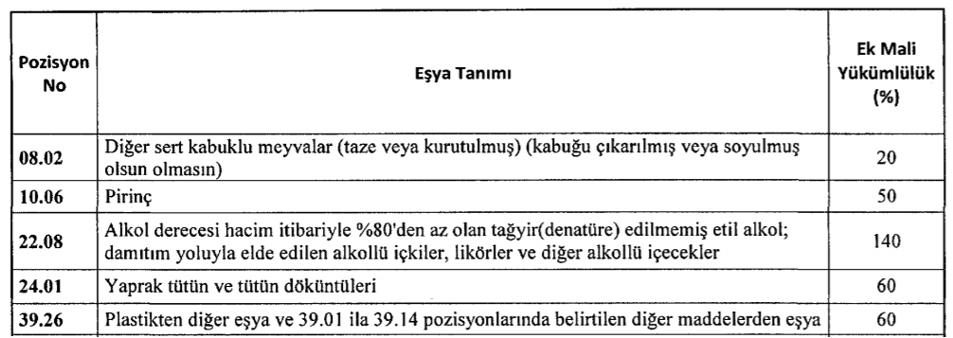
Source: T.C. Resmi Gazete
This situation blocked Turkey’s exports. Similarly, the Turkish Government did not keep in the background and countered. August 14th, 2018 — the day Turkey raised tariffs on US goods. According to T.C. Resmi Gazete (2018), new duties has placed on some American origin products and the implementation of duties on these products has also changed. Therefore, US imports affected and became expensive for Turkish consumers and companies.
3.2. Declining Trade and Boycotting
After the deterioration appeared, Turkey’s purchases from the U.S. declined within a year. However, there is not an obvious decline in imports. In contrast, after the deterioration, U.S. has a trade deficit. Census Bureau (2018) shows the U.S. Trade in Goods with Turkey.
Table 2: U.S. Trade in Goods with Turkey
NOTE: Chart indicates export and import values in millions of U.S. dollars on a nominal basis, US Exports to Turkey and Imports from Turkey.
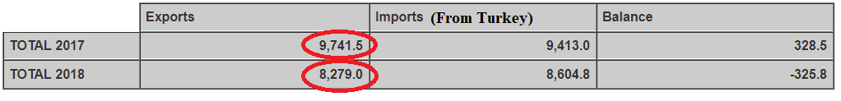
Source: Census Bureau
Thus, US exports to Turkey has been decreased by 15% within a year.
Furthermore, the President of Turkey announced the boycotting well-known US brands. Recep Tayyip Erdoğan started to encourage Turkish consumers to boycott US products especially Apple. According to the President, there are alternatives for consumer electronics rather than using American electronics (Rao, 2018). However, this invitation lost its significance because only few individuals followed the message. Here, there is an example of the boycotting issue from local press however it has no nationwide effect. Ekizler (2018) points out that the President of Turkish Restauranteurs and Confectioners Federation send a circular letter to their members not to use American origin products such as soft drinks and convenience goods.
3.3. Currency Crash
Current trade between the two countries also affected by the currency crisis in Turkey. Turkish lira is now facing downward pressure on its price which makes consumers hesitate over buying US products. The reason for this the increasing tariffs on US products has created an irritation on international markets, thereby the currency decline starts (Graham & Rees, 2018). Here, Trading Economics (2018) demonstrates that USD to TRY currency chart.
Figure 1: Currency Chart – USD to TRY
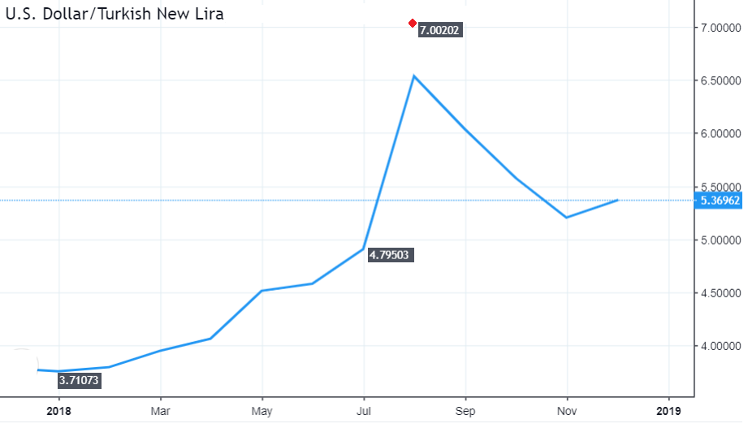
Source: Trading Economics
The US Dollar to Turkish Lira exchange rate (USD/TRY) was 3.75 at the beginning of 2018. On 18 July, the price of US dollar started to appreciate against the Turkish Lira because of Turkey’s refusal to release the American pastor and then the average US dollar/Turkish Lira exchange rate was 4.79. On 13 August, when Trump authorized a doubling of Tariffs on steel and aluminium, the exchange rate appreciated to 7.09 which was the highest price in Turkey.
The appreciation of US dollar made an effect on the Turkish economy, especially who ran into debt with foreign currencies and whose business based on imports. This situation caused impaired assets and drive companies to declare bankruptcy.
4. METHODOLOGY
In this part, the research methodology used in the study is specified. The study design and the sample are described. The method used to collect the data, including tools implemented to maintain validity and reliability of the instrument, are described.
4.1. Research Design
A quantitative approach was conducted. Exploratory research conducted through a survey. The survey questions are structured and likert scale is used. Convenience sampling method used and 30 individuals responded properly. In this study information collected through telephone and face-to-face interviews.
Exploratory research used because the subject has not been clearly defined by others. It provides reviewing available secondary data especially articles and journals to conduct a questionnaire more comprehensively.
4.2. Research Details
The study was applied to 30 individuals and started on 2 December 2018 and ended on 18 December 2018. 19 of the respondents answered the questions via telephone. 11 of the respondents (elder respondents who have communication difficulties via telephone) answered the questions by a face-to-face approach which provides detailed and comprehensible information to the respondents.
5. EVALUATION AND RESULTS OF THE SURVEY
This questionnaire administered to respondents over the telephone and some respondents were interviewed face-to-face in their homes. I have questioned 30 individuals and each of them responded properly. I used SPSS software package for understanding the results and creating cross tabulations. Respondents’ opinion about the consuming US brands according to deterioration analyzed with the survey regarding to their similar sex, age, marital status, educational level and employment status. Considering this information;
- 40 % of respondents are female and 60 % of respondents are male
- 40 % of respondents are aged between 18 and 30 years, 16.7 % of respondents are aged between 31 and 40 years, 26.7 % of respondents are aged between 41 and 50 years, 16.7 % of respondents are aged 51 years and over.
- 63.3 % of respondents are single and 36.7 % of respondents are married.
- 40 % of respondents were graduated from high school or below, 43.3 % of respondents studied undergraduate, 16.7 % of respondents studied postgraduate.
- 56.7 % of respondents are working and 43.3 % of respondents are not working.
Table 3: Gender Status Table 4: Education Level
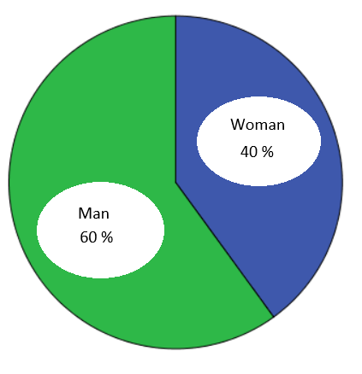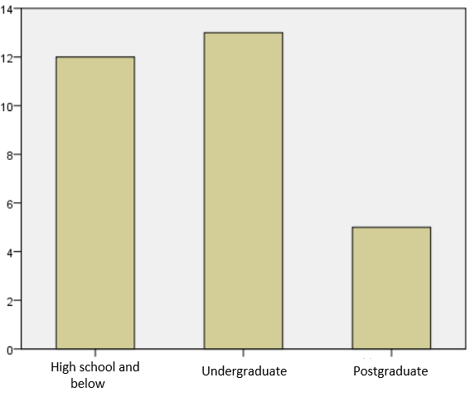
The first question was inquired into and reported whether respondents use US brands or not.
Table 5: Results in terms of Age
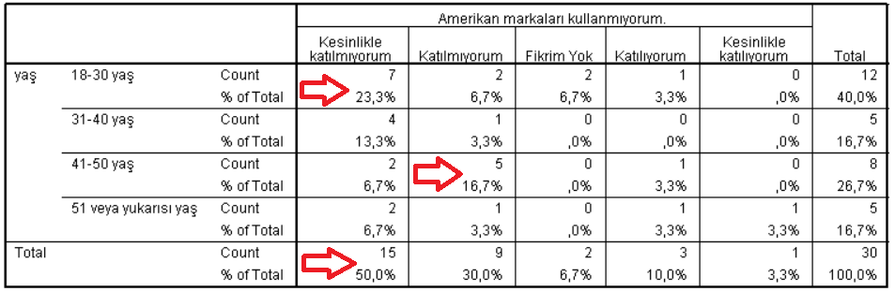
23.7 % of the respondents are aged between 18 and 30 years strongly agree with using US branded goods.
16.7 % of the respondents are aged between 41 and 50 years agree with using US branded goods.
50 % of all respondents strongly agree with using US branded goods.
The second question was inquired about understanding consumers demand for US brands after the deterioration.
Table 6: Results in terms of Employment Status
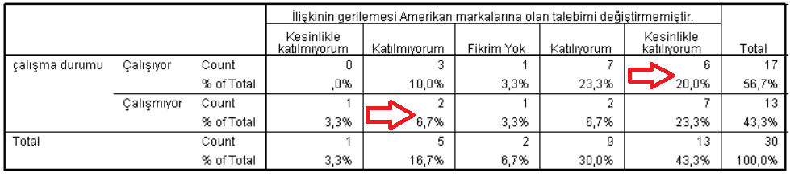
20 % of the respondents are working that strongly agree with their demand did not change by the deterioration.
6.7 % of the respondents are not working that agree with their demand changed by the deterioration.
The third question was inquired into after the deterioration consumers pay attention about using goods whether these are US branded or are not.
Table 7: Results in terms of Gender
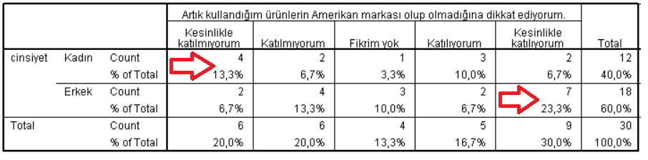
13.3 % of the respondents are female who strongly disagree with paying attention to using US branded goods after the deterioration.
23.3 % of the respondents are male who strongly agree with paying attention to using US branded goods after the deterioration.
The fourth question was inquired to understand respondents’ opinion about Turkey’s future US imports.
Table 8: Results in terms of Education Level
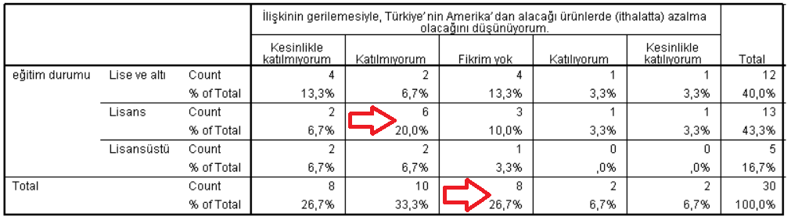
20 % of the respondents studied undergraduate who disagree with Turkey’s US imports will be declined.
26.7 % of all respondents have no idea about Turkey’s future US imports.
The fifth question was inquired into understand the respondents whether guide others to not use the US branded goods or not.

Table 9: Results in terms of Marital Status
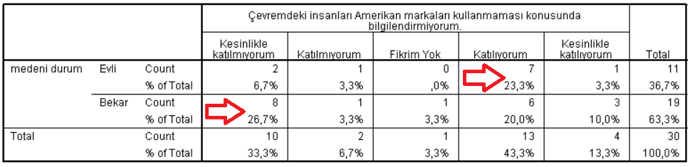
23.3 % of the respondents are married who disagree to guide others for not using US branded goods.
26.7 % of the respondents are single who strongly agree to guide others for not using US branded goods.
All of the individuals responded questions considering only shopping goods. While answering the questions, individuals considered and thought daily buying or personal consumption, not as government purchases or bulk buying. The first question expressed clearly that the most of the respondents are using US branded goods and half of them are aged between 18 and 30 years. This means that, the young generation highly involved in using US branded goods. Moreover, we can see similar consuming behaviour on the sixth table. Most of the respondents (73.3 %) are still apt to consume US branded goods. However, according to the seventh table, some of the respondents started to check whether they are using US branded goods or not after the deterioration. Thus, even though the deterioration appeared, the respondents ignored to give up consuming US branded goods and only led them to check what they are consuming.
6. CONCLUSION
To sum up, sanctions were applied by U.S. and Turkish Governments whose control over trade partnership affected immediately. Because a series of disagreements has brought tariffs at the end. Currency drops also highly concerned by the Turkish Government as foreign intervention. Most people emphasized only the political side but trade side had even worse effects. Turkey’s US imports have declined after the deterioration but there are question marks about personal consumptions. This decline is more related between Turkish importers and Government markets which include huge amounts of buying rather than personal buying. According to individuals’ perspective, some of the consumers started to stand against consuming US brands but it has a short-term effect on individuals because of the expected political developments. In contrast, some of the consumers’ opinion did not change because of the foreign dependency of Turkey. They are still apt to buy US brands.
As a result, the buying amount has declined during the deterioration considering government purchases and importers especially have an impact on a large amount of US goods buyers. The purchase unwillingness will continue on a similar trend in the short-term. Probably, these situations will be forgotten again as usual, or the relations between Turkey and U.S. will improve and also the buying level will be back into the previous level in the long-term.

7. REFERENCES

Arslan, D., Dost, P., & Wilson, G. (2018, August 7). US-Turkey Relations: From Alliance to Crisis. Retrieved October 17, 2018, from http://www.atlanticcouncil.org/blogs/new-atlanticist/us-turkey-relations-from-alliance-to-crisis

Census Bureau. (2018) Trade in Goods with Turkey. Retrieved October 28, 2018, from https://www.census.gov/foreign-trade/balance/c4890.html

Ekizler, T. (2018, August 16). Lokantacılar ve Pastacılar Federasyonundan ABD ürünlerine boykot. Retrivied October 29, 2018, from https://www.aa.com.tr/tr/ekonomi/lokantacilar-ve-pastacilar-federasyonundan-abd-urunlerine-boykot/1233127

Gladstone, R., & Specia, M. (2018, August 10). A Litany of Grievances: How Turkish-American Relations Deteriorated. Retrivied October 17, 2018, from https://www.nytimes.com/2018/08/10/world/europe/turkey-united-states-tensions.html

Graham, C., & Rees, T. (2018, August 15). Turkey escalates trade dispute with US by raising tariffs. Retrivied October 17, 2018, from https://www.telegraph.co.uk/business/2018/08/15/turkey-escalates-trade-dispute-us-raising-tariffs/

Köse, T. (2018, August 11). Türkiye-ABD ilişkilerindeki kriz ve ötesi. Retrivied October 25, 2018, from https://www.sabah.com.tr/yazarlar/perspektif/talhakose/2018/08/11/turkiye-abd-iliskilerindeki-kriz-ve-otesi

Rao, P. (2018, August 14). Turkish President Calls for Boycott of U.S. Electronics Including the iPhone. Retrivied October 20, 2018, from https://www.nytimes.com/2018/08/14/business/turkey-erdogan-apple-iphone.html

T.C Resmi Gazete. (2018) 15 Ağustos 2018 Tarihli ve 30510 Sayılı Resmi Gazete. Retrivied October 29, 2018, from http://www.resmigazete.gov.tr/main.aspx?home=http://www.resmigazete.gov.tr/eskiler/2018/08/20180815.htm&main=http://www.resmigazete.gov.tr/eskiler/2018/08/20180815.htm

Trading Economics. (2018) Turkish Lira. Retrivied October 29, 2018, from https://tradingeconomics.com/turkey/currency

United States Trade Representative. (2017) Turkey. Retrivied October 17, 2018, from https://ustr.gov/countries-regions/europe-middle-east/europe/turkey

8. APPENDIX

SEARCHING THE PUBLIC OPINION AND DEMAND FOR US BRANDED GOODS AFTER THE DETERIORATION OF RELATIONS
This questionnaire is designed for International Business Research Methods which I have taken the course at Cankaya University Department of International Trade. Please answer the questions. Thanks for your contributions.
Emre Şentürk
PART I
- Gender ( ) Female ( ) Male
- Age ( ) 18-30 ( ) 31-40 ( ) 41- 50 ( ) 51 and above
- Marital Status ( ) Married ( ) Single
- Education Level ( )High school or below ( ) Undergraduate ( ) Postgraduate
- Employment Status ( ) Working ( ) Nonworking
PART II
No | Please state your participation level by marking with ‘‘X’’ next to related expression. | Strongly Agree | Agree | No Idea | Disagree | Strongly Disagree
01 | I do not use US branded goods.
02 | After the deterioration, my demand for US branded goods has not changed.
03 | After the deterioration, I started to check products whether US branded or not
04 | After the deterioration, I estimate that Turkey’s Imports from the U.S. will decrease.
05 | I warn people not to use US branded goods.

